People Power - FAQs

How did you get feedback from your mystery shoppers? How did you listen/watch? (Alison – Living Sport)
We held launch events so our mystery shoppers could meet up at the start of the project. We kept it simple and took laptops and tablets along for women to search for activities. We held the events in local community halls and other familiar spaces and created a relaxed environment with cuppas and informal chat. We asked the women how they would normally search for activities and then invited them to do that in pairs and chat about the activities they found. This meant we could sit back and listen to their reactions and questions, as well as observing what they typed into Google to search for activities. The conversations were often quite animated as they either got excited about activities or frustrated by being unable to find the information they wanted. It was often quite a rollercoaster as they got excited about something and then got to information about cost or ability which was unclear and that put them off. Occasionally they asked us questions about what would be expected of an ’improver’. And if they reacted negatively towards something we asked them questions to ensure we understood why.
Through the process we developed a short checklist of the key info the women wanted. Although the list is quite basic, this information was very rarely all available in one place for an activity. Often the bigger providers were the ones that offered the least information.
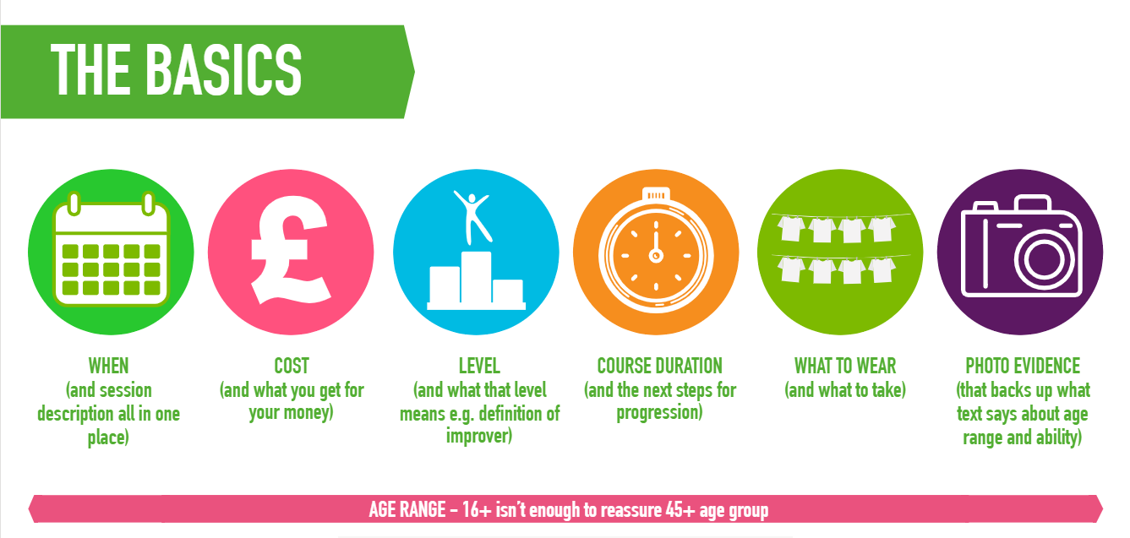

Did you at any point draft something and put it in front of people for comment or was everything co-created from scratch? (Ali Wills – Active Cornwall)
We didn’t draft anything to put in front of people. Here’s the webpage that we set up to invite people into the conversation We Can Be Active – Join the big conversation We posed 3 questions:
- What matters to you
What does being active mean to you? What do you do to incorporate movement into your life? What or who motivates and inspires you to be more active?
- Barriers and opportunities
What makes it difficult for you to be active? What would you like to see started or changed to make it easier and more appealing for you, your family or your community to be more active?
- Imagining our future
If you had a magic wand, what would the future look like if everyone in our communities could be active on their own terms?

What has been the story of the system listening to the voice of people? (Simon Penhall)
Development of the physical activity strategy – following the online conversation we held, we presented the ideas and comments from our communities to a range of organisations from across the system. We were challenged about the number of people reached – but we mapped their comments against evidence from the World Health Organisation to show that the two things were saying the same thing. Some of the comments from communities are being included in the Local Transport Plan which is currently being developed.
Mystery shoppers – activity providers were receptive to listening to feedback from our mystery shoppers. One leisure operator has made changes to their website so that their session descriptions and timetable now appear in the same place, which was something the mystery shoppers had got particularly frustrated with when trying to navigate the website. In some cases the activity providers challenged feedback but this allowed us to open up positive conversations and gain a better understanding of both sides of the story. For example, some were reluctant to change imagery because it works for their core fitness market who are their primary source of income. We now know we need to build a stronger case to addresses this concern.

What did you learn from your customers being involved in the feedback loop? (David Coulson – Living Sport)
Mystery shoppers - we learned that their feedback is powerful. In the past our feedback to activity providers has been along the lines of “research says this and you need to do this.” It was all quite theoretical and felt like us in our office telling people who deliver activities what to do. With the mystery shoppers’ feedback, we were able to change the message to “These local women want to do the type of activity you offer but your activity didn’t show up in their search/this thing on your website put them off/they joined and this happened”. It was much more practical and equipped them with simple changes that could easily be implemented. We were also able to widen that message to make it applicable to a larger number of activity providers by using summaries like the checklist above to encourage providers to check and challenge their own digital channels.
We also uncovered some of the sticking points at which motivation to find an activity drops off. Our mystery shoppers had lots of questions where they would have had to email or phone someone to ask about membership/equipment/ability level. They all said they probably wouldn’t bother and would just give up at that point. These are relatively simple issues to address that could have a big impact and ones that we, as an Active Partnership, are well equipped to address.

Can you say a bit more about ABCD training? (David Shipman)
Asset Based Community Development is one approach to try and bring about sustainable change in communities. The principle of the approach is it starts with what matters to the community, identifying the strengths and skills which already exist there, identifying what they’d like to do and what support they’d like from organisations working in the place. It’s a 2-day training course run by Nurture development (I’m sure there are other providers) – more info can be found here https://www.nurturedevelopment.org/asset-based-community-development/.

Did you have internal resistance to the approach? (Chris – Energize STW)
No – each team member is at different stages of embedding seeking community voice in their work but it’s becoming more and more accepted as a way of working across the team.

How do you bespoke this approach to all the diverse communities across H& IOW …..do you feel that you can scale it up sufficiently? John Byrne – Leicestershire
You can apply the principles of ABCD in many aspects, if not all areas of your work. A strength-based approach to all our work.
Energise Me can’t work with all diverse communities in all areas of Hampshire and the Isle of Wight. It’s a huge geography, 3 unitary authorities, 1 County and 11 districts. Even if it were smaller, it wouldn’t be possible to work with all diverse communities.
We have worked with our board to build an evidence base of which audiences and places to prioritise and why. So 3 years ago, the team (Board and staff) took a forensic look at all the data and insight we had available to us. Based on the analysis, we identified 3 priority audiences and one place where we could test approaches and ideas. We have shared the learning with partners so that they too can apply the learning. Effectively, we have been trying to grow a network of supporters who can apply the learning in their own areas and organisations. In this way it is possible to scale up the work without increasing your head count.
Place based work is slightly different perhaps. We knew where we wanted to work but we didn’t have the interest and support amongst local authorities or other partners in those areas to work with us. The Board therefore took the decision to invest in our most inactive community to test the principles of a place-based approach. We have a list of other places where we need to take a place-based approach and we are experiencing other parts of the system wanting to test this too. Health especially. If this progresses, additional investment comes into the system and you begin to build scale.

Did you target specific demographics of people? (Mark Sherwood – Active Surrey)
Yes – through the online conversation we were particularly interested in the groups we knew to be least active. Our promotion of the conversation looked specifically at where we could reach these groups – for example Womens Business Networks, social media which we knew to be used by Mums etc. Facebook ads were used to reach over 60s – this method particularly worked for 65+ women. We also targeted our network of health contacts – CCG’s, social prescribers, local charities supporting people with specific conditions to get the message out.

How did you actively engage with 'people' in your places to become trustees? Gemma Finlay-Gray – Active Sussex)
We were explicit in our recruitment adverts:
The team are looking for individuals with skills/experience in at least one of the following:
- Working with teenagers
- Supporting people with long-term health conditions – particularly in a clinical commissioning or mental health context
- Supporting women in a charity, community, or physical activity context
  - Asset-based Community Development experience and/or strong local connections within the Redbridge and Millbrook area of Southampton
- Charity leadership and/or campaigning
- Monitoring and evaluating social and/or economic impact
- Facilitation and/or collaborative action planning skills
- Expertise in behaviour change or innovation in a health context

Relationship building played a big part too. We had connected with one of the new trustees at an event and stayed in touch. When we were advertising the role, we circulated the advert to her to take a look as well as to circulate amongst her networks in the community. We had also connected with many people in the place and contacted them directly to raise their awareness. We emailed, phoned and used every opportunity we could across our team to raise awareness to our recruitment campaign.

Did your work on your team values go alongside the ABCD work or was it before/after? (Louisa Arnold – Kent Sport)
Values were developed before we left our host organisation and moved into our new, independent organisation in 2016. The team decided which values were important to take with us, those we needed to leave behind and those that we needed to help us deliver our new strategy and new ways of working. We have been steadfast with our values and they have and continue to serve us well. All new staff are fully inducted to our values and see them modelled by colleagues on a daily basis.

As well as a party, what helped engage local people to gather their insight at the Pub consultation. Did the approach work as expected? Ronan McMahon)
Prior to the party, we walked the streets of the estate, finding out about groups that existed and people that were already doing great things in the community. This gave us a great ‘invite’ list from which to start from. Every time we met a new group or organisation, they told us about someone else they knew. This took about a year to do before we had the party and involved approx. 3-4 members of our team. We’re now looking to appoint a p/t community connector who can carry this work on.

